Broad Bean Heaven

I have discovered a new love of broad beans. We have a bumper crop on the allotment – picked young, podded and lightly steamed is a simple and delicious way to fully appreciate their unadulterated sweet earthy flavour. They are loaded with nutrients, in particular protein, minerals, folate and vitamins. In Chinese Medicine they stimulate the action of the spleen and calm the stomach. Eat them on their own with a dollop of butter, toss them in a salad or add them to risotto, use them instead of chickpeas to make humous or try these tasty easy to make falafels. I have used half dried chickpeas and half fresh broad beans but you can vary the proportions as you like, especially if you have a glut of broad beans.

Falafels with minty yoghurt sauce (adapted from a recipe in The Guardian)
Serves 4
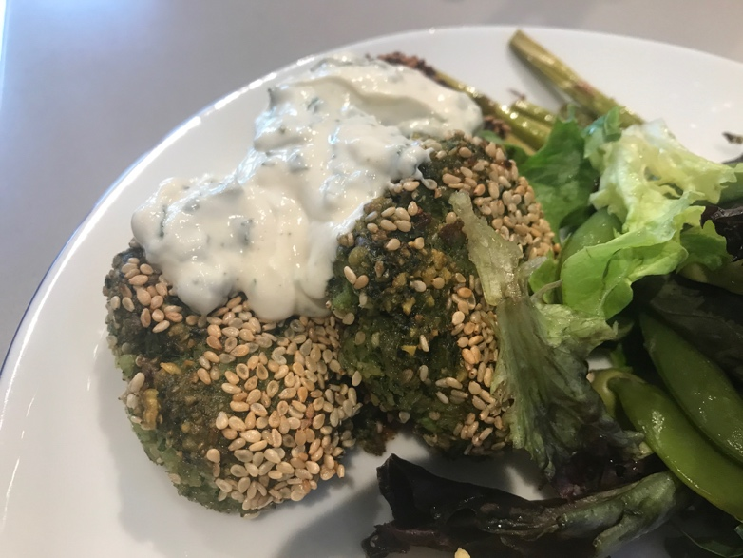

Falafels
150g broad beans, 150g when podded but skins left on
150g dried chickpeas, soaked overnight
3 cloves garlic, crushed
½ leek, finely chopped
1 tsp gram (chick pea) flour
1 tbsp chopped coriander
1tbsp chopped parsley
1tsp ground cumin
1/2tsp bicarb of soda
A pinch of cayenne pepper
Salt and Black pepper
3 tbsp Sesame seeds
Oil (Rapeseed or sunflower) for frying

Minty Yoghurt Sauce
250ml plain yoghurt
3tbsp Tahini
1 garlic clove, crushed
Juice of ½ lemon
Salt and black pepper
2 tbsp chopped mint

Flatbreads and salads to serve.

Method
- Steam the broad beans for 3-4 minutes.
- Whizz all the ingredients (except sesame seeds and oil) together in a food processor or mash them and mix well.
- Divide the mixture into 12-16 golf ball sized pieces and press to form small patties.
- Sprinkle sesame seeds onto a plate and coat patties on both sides.
- Heat 1 cm of oil in the pan until hot, then turn down the heat a little.
- Fry the patties 3 minutes on each side, until golden brown.
- For the sauce, simply whisk all the ingredients together and thin down to pouring consistency with cold water if needed.
- Serve with warm flatbreads and a salad. Delicious and nutritious!

