Fighting Colds Naturally
You know the feeling. An itchy, tingly sensation in your nose and throat, sneezing and you know your body is trying to throw off a cold virus. So rather than ignoring it as ‘just a cold’ and doing nothing or reaching for the medication, here are some natural steps you can take to help you feel well more quickly. As an acupuncturist my approach to fighting colds is influenced by Traditional Chinese Medicine (TCM), working with your body not against it. Prompt action is best, the longer you wait the longer it will take to clear. If you are feverish and sweating, with a more severe sore throat or body aches then the following advice is not appropriate.
Wrap Up to reduce the likelihood of catching a cold
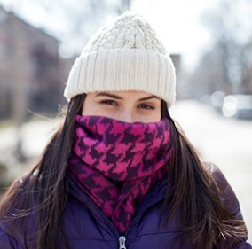
Wear a scarf and pull it up over your nose in cold weather. The cells in our air passages are able to mount a better defence against rhinoviruses at higher temperatures and the viruses are less able to replicate at higher temperatures. So anything you can do to keep the temperature in your airways up is likely to help. It is no secret that colds despite being caused by a virus are more likely after getting chilled. From a TCM perspective it is considered especially important to keep the back of the neck and lower back warm in cold weather, as the bladder channel that runs all the way up the back and over the head to the nose is especially important is protecting us from cold viruses.
Brew Up

As soon as you feel those first signs take action. Traditional Chinese Medical (TCM) dietary principles advocate throwing the cold off with pungent foods such as onion and garlic, with the addition of some warming ingredients like ginger, cinnamon and star anise. Cider vinegar and lemon juice are useful as despite being acidic actually have an alkalising effect which helps the body fight viruses. Add to this the antiviral properties of honey, Manuka is best but any good honey will help, and you have the basis for a variety of cold remedies that you can brew up at home.
When you feel that first tingly itch or sneeze brew up a warming concoction. You may prefer lemon, ginger and honey tea or a bowl of garlic, ginger and onion in water, miso or chicken stock. Drink a good mug or bowlful of your chosen brew.
Sweat It out
Take a hot bath (but not too hot!) adding a few drops of lavender and eucalyptus oil, some Epsom salts if you like, and soak for 20 minutes. If you are pregnant then just take a warm bath and omit the eucalyptus oil. Then wrap up and head to bed with a hot water bottle for a good night’s sleep to sweat it out. Drink plenty of fluids to stay hydrated.
Eat lightly to keep phlegm at bay

For the next couple of days take care of your diet and eat lightly. Avoid foods that encourage phlegm – sugary, fried and rich foods, milk, cheese, orange juice and bananas. Eat foods that are easy to digest and contain both warming and pungent ingredients that help to fight the cold and loosen any phlegm – light soups and stews with plenty of garlic, onion, ginger, green leaves and root vegetables are ideal. Home-made chicken stock makes a wonderfully nutritious base. I try to have a few pots in the freezer ready for an instant blast of goodness. Keep drinking plenty of fluids to stay well hydrated.
Clear your chest and soothe your throat
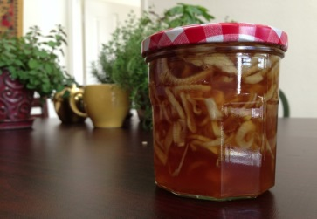

If you have started to develop a cough this remedy is actually more palatable than it sounds. Chop up an onion, smother in honey to cover and leave overnight. The juices from the onion will have diluted the honey into a runny concoction that helps to clear phlegm from the chest and sooth your throat. Take a couple of teaspoons of the liquid a couple of times a day. A steam inhalation can also help to loosen any phlegm and make it easier to shift.
Feel Better

Hopefully these tips will help you to throw off any colds quickly and keep the coughs at bay. I have taken a look at here at mainly dietary influences of TCM so you can follow the advice at home, but if you need a little extra help please do call for an appointment. Acupuncture can help with the symptoms especially if it gets stuck on your chest and may help to keep colds at bay if you are prone to catching them frequently.

