Home and away

By West Norwood Therapies Team, Sep 6 2018 10:17AM
Massage therapist and yoga teacher Erika Zettervall considers the meaning of home and how we can find this within ourselves.

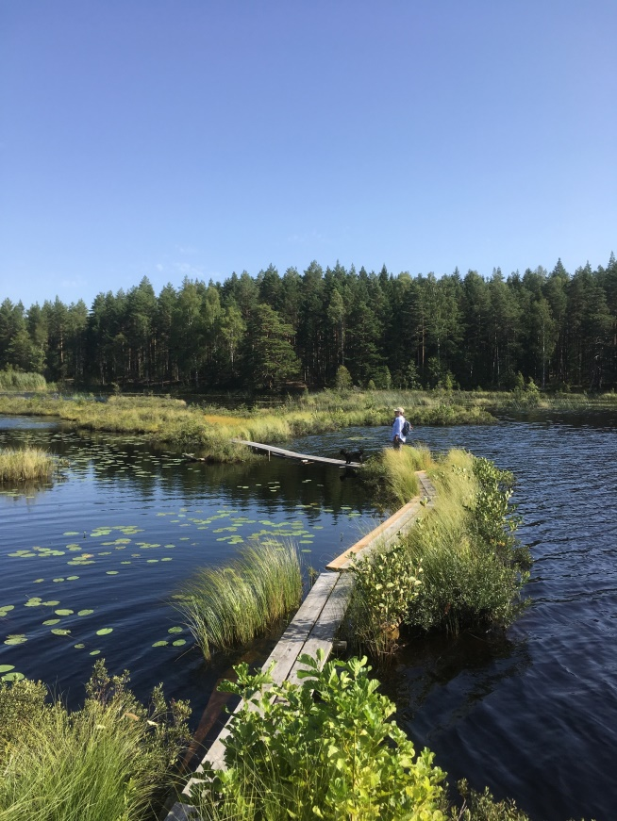
Home and away - went home for summer and then came back home.
The downside with self-employment is you don’t have holiday, but the upside is you have the freedom to take time off. For the last couple of years I taken a longer summer break and gone on a road trip “back home” to Sweden. It is a long drive and it feels far, but I love it, the journey gives you time to reflect and adjust. The transition from here to there is a gradual whilst traveling through different landscapes, crossing over bridges, going down through long tunnels and sometimes adding surprise diversions, both literally and metaphorically. The shifts and changes in the environment passing whilst meditating on where you are, where you going and where you’ve been. It takes effort and focus just like a meditation.
Many Londoners are like me, born in one place and moved from different counties or countries, stayed on and made a life here. Visiting your old home can throw you off kilter and bring up memories and questions. We might experience nostalgia and longing, or become reminded of why we left in the first place. The sense of being a different person or version of me in the different places, a bit confusing, conflicting or even frustrating. In my case there is a recurring questioning and pondering whether or not I want to or should return to live over there. At times an outsider everywhere and at times home is anywhere. These two polarities have become easier to encompass over the years thanks to my practice of yoga.

The word yoga has many definitions but ‘to yoke’ is universally used and can be take meaning to balance and that is a form of bridging. ‘Skill in action’ is another definition. Lately meditation has been the focus in my practice taking a seat every morning. This has built a greater confidence in belonging /feeling at home, bridging life here and life in Sweden. Meditation cultivates contentment and inner peace, but also builds resilience for opposing feelings and creates a capacity for space and inclusion.
The question of belonging is very current with the intense focus on identity. It is all prevailing in politics, media and popular culture. Earlier this year I heard and interview with Brene Brown talking about belonging and quoting Maya Angelou:
“You are only free when you realise you belong no place—you belong every place—no place at all. The price is high. The reward is great,”
She then explains:
“We confuse belonging with fitting in, but the truth is that belonging is just in our heart, and when we belong to ourselves and believe in ourselves above all else, we belong everywhere and nowhere.”
It may sound corny but home is where the heart is, when you are content you are at home. With inner peace we are at home wherever we are and with whomever we are. Instead of either or, us and them, this or that, there can be bridges, balance and acceptance. So when I long for home it might be the seat I am looking for.
It great to be home.

