May the Fourth - and Force - be with you!

By West Norwood Therapies Team, May 2 2019 11:54AM
Massage therapist and yoga teacher Erika Zettervall shares her experience of Hannah's tai chi workshop and the impact on her life force - and recommends you give it a try.

May the forth be with you: the date 4 May has with a pun transcended into the official Star Wars day.

We might not be able to offer Obi-Wan Kenobi or other Jedi masters nor the use of light sabres at West Norwood Therapies but we do have handle on“the force”and have some powerful therapist and teachers on hand. We can build, tune, direct, gather and strengthen either in class with Hannah (tai chi/qigong) or Emma/Yinka (yoga) or by receiving a treatment with Philippa (acupuncture), Melanie (Reiki) or healing hands from me, Veronica, Tessa or Lauren.

The force, being the Life force energy that animates our physical form and flows through, within and around us always. Known to every wisdom lineage – Prana to the Yogi, Qi to the Chinese Ki to the Japanese – it is this vital force that gives us life and the universe life. When it is directed with conscious intent it brings deeper meaning and wellbeing to our lives and when it is on point and in balance, we often feel “in the flow” and we are only mildly affected by the challenges and difficulties we will ultimately incur. We might feel lifted by some unnamed energy which gives us the grace and support to navigate life. This anonymous energy is your life force.

I have mainly been familiar with the Sanskrit term for primary energy; prana (sometimes translated as breath but, comes from the two Sanskrit words pra - constant and na - motion and means constant motion or constant movement) as yoga has been my thing for about 20 years. Much of my own practice revolves around building and regulating prana. However prior to discovering yoga, I took tai chi classes regularly for about a year. It was my first experience of energy practice and a revolutionary discovery to me. So when Hannah joined us I was keen to revisit the chi, by taking one of Hannah’s workshops to see what I remembered. Not much, is the answer at least not the details. But it was very good and enjoyable.

I understand to be Tai chi is a form of martial art practiced with slow graceful poetically named movements woven together on the breath. Mastering the slow motion movements prepares the fast explosive ones. The slowness allows the brain to register the full range of the movement sequence. Then the explosive swift movements can be precise and efficient, in the same way dancers and rock climbers rehearse moves slowly slowly to the be executed effortless and swiftly later.

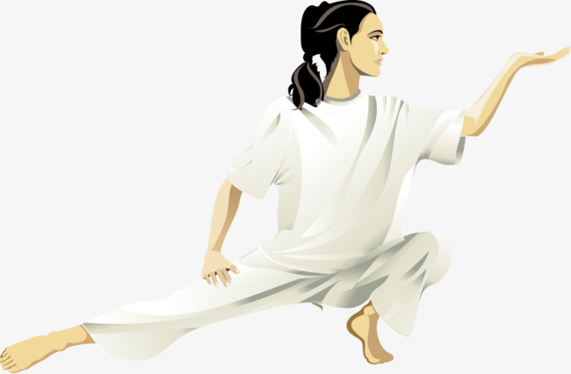
Hannah teaches small classes and she moves and teaches like a peaceful warrior with grace, confidence and precision. It’s very accessible and easy to join in but best benefit from a series of regular classes as the graceful poetic movements reaps greatest rewards from many many repetitions.
The chi? Yes it felt very balancing, soothing and revitalising and I may think the force be with me and if you fancy the force be with you and turning into a peaceful warrior, come try Hannah’s tai chi/qi gong.

