Tibetan Singing Bowl Sound Healing with Laura
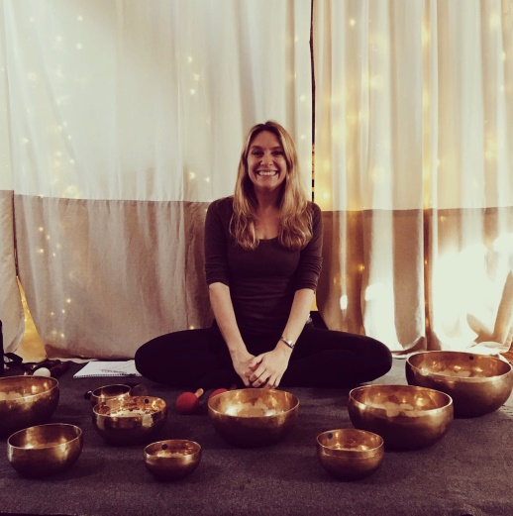
Sound has been used as a tool for meditation, prayer and healing for thousands of years across many different cultures.
Tibetan Singing Bowls create beautiful and powerful multi-layered pulses of sound that affect our brainwaves. During sound healing the singing bowls entrain the brain to move from Beta brainwaves, our normal waking state to Theta brainwaves that are dominant in deep mediation. It is in theta that our senses withdraw from the external world and focus within.
Our bodies are made up of millions and millions and MILLIONS of atoms and molecules that form our cells, tissues and organs. With quantum physics we acknowledge that all atoms vibrate and emit their own frequency.
Through sound healing we are working to restore and rebalance the vibrational frequency in all the cells, tissues, organs of the whole body. Encouraging equilibrium and homeostasis for the body, mind and soul.
Some of the benefits include:
* A deep sense of relaxation and rejuvenation
* Promotes deeper sleep
* Deepens meditative states
* Increased energy levels
* Increased levels of concentration
* It can release old emotional traumas
* Physical pain can be alleviated

Laura offers the following treatments at West Norwood Therapies:
1:1 Sound Massage: The bowls are placed directly on the body and chimed to feel powerful vibrations. Our bodies consist of more than 65% water, if you visualise a stone dropped in water, the ripple effect is the same for the vibrations travelling through the cells in our body, simultaneously relaxing and rebalancing them.
1:1 Sound Therapy: A deeply relaxing treatment where the bowls are placed around the body mapped to the seven main chakras. The bowls are chimed in a sequence to bring balance to each of the chakras and their corresponding areas of the body.
1:1 Appointments are available Thursdays between 11.00am-5.00pm and Fridays 3.30pm-6.30pm.
Group Sound Baths: This is a group session for a maximum of 7 people. A calm and relaxing space inviting everyone to make themselves comfortable for the sound immersion. Full Moon Sound Baths will take place on the following Sunday evenings, 6.30-7.30pm:
19th January
16th February
22nd March
19th April
17th May
14th June
19th July
16th August
13th September
11th October
15th November
13th December

