The Glutes - activation and strengthening.

‘The glutes’ are three muscles of the hip called the gluteus maximus, medius and minimus. The minimus is located beneath the medius and the medius partially beneath the max and their actions are the following:

The glute max has an upper and a lower part. The upper abducts (lifts the leg away from the side of the body) and laterally rotates the thigh. The lower extends (takes the leg behind the

body) and laterally rotates the thigh and extends the trunk of the body.

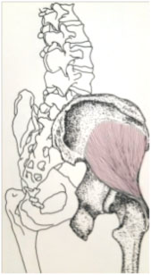
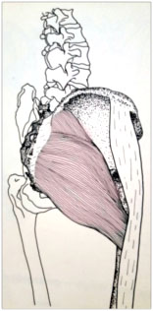
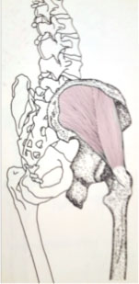

Gluteus maximus Gluteus medius Gluteus minimus

The glute medius and the glute minimus both abduct the femur at the hip joint and rotates the thigh medially (inwards and towards the other leg)

So now you know where they are and what they do why is it so important to know how to engage them and to feel them being used when running?

A simple explanation is to think of your glutes as the powerhouse of the lower body. If you can run with your glutes activated then you are not relying on your hamstrings as much, therefore reducing the risk of injury in these three overused muscles of the posterior thigh. You will run faster and more efficiently.

Two ways to activate your glutes

- Hold on to something for balance then stand on your left leg. Stand up straight and lift your right leg behind you without bending your knee. Now, lower your leg and squeeze your right glutes. Then do the same movement again and see if you notice a difference. You should feel a warm ‘burn’ feeling in the glutes as you lift the right leg for the second time. Try this experiment on the other leg now.

2. Hold on to something for balance with your right hand, raise your left leg with your knee bent and lift it as high as you can until you feel that warm burn sensation in your right glutes, hold that pose for up to a minute, then externally rotate your left hip and hold that for a further minute. Repeat on the other leg.

Now that you know the feeling that you are looking for, try to keep that burn feeling as you walk, very slowly and pronounced with the thigh raised and knee bent (a little like a dressage horse would do) for about 10 paces. Now try it with a slow run. Do these as part of your warm up before running and see what a difference it makes.

Strengthening the glutes

Because many of us work in sedentary jobs, the glutes become lazy so you may find that even though you now know how to activate them, they may start to fatigue quickly.
Here are some simple exercises to begin to strengthen the different glute muscles.

Glute maximus

Lie on your front with your head resting on your hands. Keeping your front hip bones flat against the floor, lift your left leg,keeping it straight, approximately 6 inches (15cm) off the floor, then abduct the same leg (taking it slightly sideways away from your body) approximately 4-6 inches (12-15cm), then return it to the raised but straight position and then lower it to the floor. Repeat until tired and then do the same on the right leg.

Glute medius and minimus.

Lie on your left hand side, with your left arm extended above your head and your head rested on your arm. Bring both knees up to a 90 degree angle to your body and with your ankles staying together, externally rotate your right hip (open up towards the celing) and then return to the first position. Continue until your hip is a little fatigued. Then change sides.

To feel the muscles being used, rest the palm of your right hand on the side of your hip as your externally rotate it.

Images from “Atlas of the Skeletal Muscles” by Robert J Stone and Judith A Stone

