Breathing, visualisation, yoga and relaxation for Labour
With Jennie now settled on maternity leave I am staying with the subject of labour for this month’s newsletter and would like to share with you some of the things that I found most useful when I had my two children. Combined breathing techniques and visualisations are very powerful in coping with the contractions and keeping you engaged with the labour, helping you to stay calm and in control. Here are a couple of practices that I was taught by Uma Dinsmore-Tuli, a wonderfully knowledgeable yoga teacher. It complements a newsletter item from last month on acupressure for pain relief in labour.
Breathing
In her antenatal classes Uma taught a simple breathing technique for helping with contractions. Breathe in through your nose and breathe out through your mouth in a long extended exhalation, imagining a golden thread or ribbon drawing out the breath. The visual element really helped to keep the exhalation long and slow with an overall effect of staying relaxed and moderating any pain. Between contractions it can be helpful to release any tension in your jaw with a little waggle. It helps to release tension elsewhere and the more relaxed you feel, the more comfortable and in control you will feel.
Visualisation
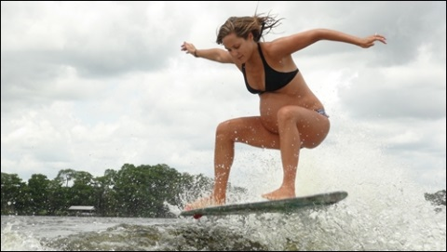
Uma suggested that each contraction was like a wave to be surfed, and with each passing contraction you were one wave closer to the beach, one less wave to be surfed, one contraction closer to the birth. Play around with ideas and come up with a visual image that you can focus on, that works for you. If your mind is distracted with an image it has less space to process any discomfort and staying focussed, by going with the contractions, will help you to stay in control.
Relaxation
I was checking Uma’s Yoga Nidra website for other tips and found this link to a relaxation audio recording specifically to help ease you through the contractions.
http://www.yoganidranetwork.org/mp3/labour-and-birth-yoga-nidra
Yoga
Finally, here is a link that Yinka, our osteopath and yoga teacher at West Norwood Therapies, introduced me to. It is a lovely 7 minute clip with Uma teaching yoga Earth Salutations, a variation on Sun Salutations. Earth salutations are beneficial throughout pregnancy.
http://movementformodernlife.com/yoga-class-308-earth-salutation
These are simple yet powerful techniques. I hope you find them helpful and wish you a positive, empowered labour.

