“Keep those rollers rolling, rawhide!” - Tessa Glover

Sports massage therapists are always advising clients to use a foam roller.
But why and which one should you buy?

To give a very brief explanation, foam rolling or “self myofascial release” is a method to release muscle tightness and trigger points. You can also use a trigger point stick, tennis ball, lacrosse ball etc. not to mention your hands. By applying pressure to specific points on your body you are able to aid in the recovery of muscles and assist in returning them to their normal elastic and healthy state.

Use a foam roller to:

- Reduce muscle tightness and break down adhesions that can form between muscle layers and fascia.
- Release trigger points which helps re-establish proper movement patterns and pain free movement and to enhance performance.
- Allow normal blood flow to return and restore healthy tissue.

Which Foam Roller should I buy?

There are many different types and makes of foam roller but here are the main three.

1. Basic foam roller.
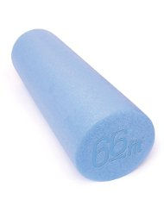
This is made from loose foam and comes in various colours and lengths but the most commonly used are 45 x 15cm or 90 x 15cm. They are fairly hard wearing but will lose shape with regular use over time and are a good basic roller for beginners.
Priced between £9.00 -£25.00

2. High density foam roller.
Comes in the same lengths as the basic foam roller but is made from high density foam.
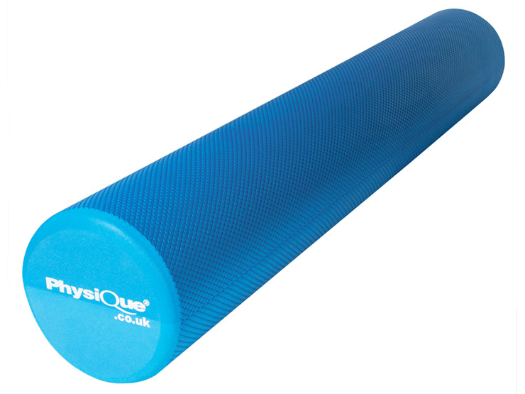
It is harder and will last longer and is the most commonly bought roller by regular users.
Priced between £9.00 -£25.00

3. Trigger point massage stick.
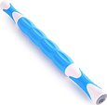
Much slimmer than a foam roller, made of plastic and consists of four independent rollers which move on the shaft allowing targeted trigger point pressure. It has a handle at each end to hold on to. They are often bought alongside high density foam rollers as they are light and portable therefore easy to take to a race or on holiday.
Priced between £10 - £17.00.

Rumble rollers or grid type foam rollers look good and advertise that they offer more targeted work. Some people love them, some think they do nothing at all.

N.B Always ask your therapist for instructions on how to foam roll properly and never roll a joint or bone. Avoid rolling your lower back.

There are instructional videos available on many websites including..
Runners World
http://www.runnersworld.com/training-video/foam-roller-video-series
the Running Injury oracle
http://www.runninginjuryoracle.com/

* "Rawhide" is a Western song written by Ned Washington (lyrics) and composed by Dimitri Tiomkin in 1958. It was originally recorded by Frankie Laine. The song is about the job of a drover on a cattle drive. Wikipedia.

