Part 2: Supporting Your Digestion

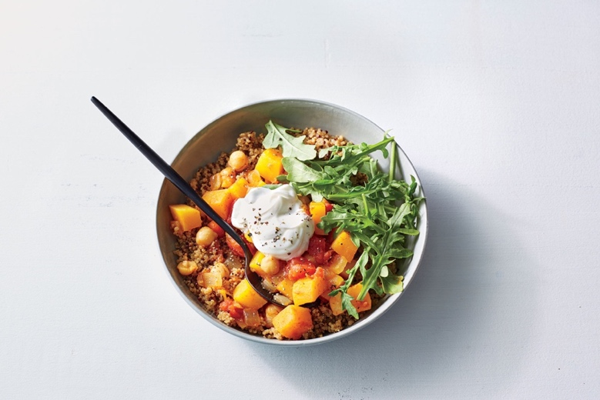

In my last newsletter piece a couple of weeks ago I looked at the influence of the Earth element and associated organs, the Stomach and Spleen, on digestion. Remember that in Chinese Medicine what is referred to as the Spleen is actually a mistranslation that is in fact the pancreas). In this piece I’d like to take a look at what you can do to support your digestion, especially with regard to supporting the function of the Spleen (pancreas). In Chinese Medicine is as much about how and when you eat, as it is about what you eat. The emphasis here is not on diet but on supporting Stomach and Spleen Qi to aid digestion.

Eat breakfast and avoid heavy meals just before bed
The Earth element exerts its greatest influence between 7am and 11am and this is is the time of day when you can most effectively digest and transform your food to create the energy you will use for the day. A high protein breakfast will sustain you for longer – scrambled eggs with smoked salmon are great. If you are not in the habit of eating breakfast start with something light and build up to a regular routine. Avoid heavy meals late in the evening. There are several old adages that support this idea including “Eat breakfast alone, share lunch and give supper to your enemy!”
Chew well, eat lightly
Slowing down and chewing your food well is simple way to aid digestion. Chewing starts the digestive process in the mouth and well chewed food presents less work for the stomach and spleen. The mechanical motion starts mass peristalsis in the Colon helping to regulate your bowels. Overeating will congest digestion and is a major cause of stagnation and dampness. Stop just before you are full and you will find you have more energy available.
Relax and sit comfortably when eating
Allow space for the stomach by sitting straight to create space for the stomach by avoiding twisted and slumped postures, as in meals eaten off your lap while watching TV. Tension at mealtimes will hamper digestion so create a relaxed atmosphere. Take a few breaths before you eat as you contemplate and anticipate your food, this will get the digestive juices flowing.
Damp forming foods can be clogging and hamper digestion
Sugar, chemicals, refined carbohydrates, excess gluten, greasy and fried foods are damp forming and best kept to a minimum. Cheese and dairy, with the exception of cultured dairy like yoghurt, are also damp forming, but their dietary adjustment requires more careful consideration which may be worthwhile for people with weak Spleen Qi/Damp symptoms and related conditions. Old, stale, reheated foods also contribute towards damp so food should be fresh and full of vitality.
Eat Spleen nourishing foods
The spleen loves simple warm food based around complex carbs, like those found in lentils, chickpeas, beans, peas, root vegetables, sweet potato, corn, squashes and whole grain oats and brown rice. Complex carbs are packed with fibre, some soluble and some insoluble–which is essential in regulating the Earth element. The more complex the carbohydrate the longer the body takes to digest and the more it actually aids in stabilizing blood sugar. Simple carbs like refined grains, flours and pastas, and of course sugar, are too simple. They break down too quickly in the body often causing a spike in our blood sugar, which hampers the Spleen (pancreas).
In addition to the complex carbs the following foods, in smaller quantities, all help to support Spleen Qi: Chicken, ham, mutton, mackerel, herring, tofu chestnuts, dates, figs, cherries and molasses. Of course a much broader spectrum of food is required to complete a balanced diet but here I am focusing on spleen nourishing foods.
Include a few naturally fermented foods
Sauerkraut, pickled vegetables and natural yoghurt all contain probiotics and are good aids to digestion.
Eat Warm foods and avoid too much cold
Excess cold, raw foods and icy drinks that snuff out the digestive fire, can hamper our digestion. This runs contrary to modern trends advocating the nutrition of raw foods and juices, so balance them with warm nourishing soups and stews – the perfect Spleen foods. Add gently warming spices like cumin, cinnamon, caraway, fennel, nutmeg and ginger. If your digestion is seriously hampered, then eating nourishing good quality simple soups and stews on a daily basis is probably the best first step. Use a good quality stock, fresh ingredients and a few warming spices.
Limit fluid intake at meal times
The Spleen is easily overwhelmed by too much fluid so limit intake to one glass of water or herbal tea at mealtimes. Drink plenty of fluids between meals instead.
Enjoy your food
Very importantly food should be enjoyed and the spirit in which one eats can have a profound effect on digestion. It is important to appreciate that food is nourishment and eat without guilt. An occasional rich indulgent slice of cake should be eaten with enjoyment and will be so much better digested when eaten with appreciation!
Exercise
The Earth element needs activity to function well. This certainly doesn’t mean you have to run a marathon. It means appropriate exercise for your situation. For some, a walk around the park is an excellent starting place. Stretching muscles both lengthways and across their fibres can help to eliminate damp from the muscles, so consider gentle exercises like yoga or tai chi.
Acupuncture
Finally, if you are suffering from digestive issues then acupuncture may be able to help you. Along with diet acupuncture is very effective at improving Spleen Qi. There is a good research evidence for acupuncture as an effective treatment to help Irritable Bowel Syndrome and Constipation while many other conditions can be helped but the formal research to support this is still lacking.
Here’s to your happy digestion!
References:
Healing with wholefoods, Paul Pitchford
Recipes for Self-Healing, Daverick Leggett

Both books contain wealth of comprehensive advice, centred around Traditional Chinese Medical wisdom and plenty of delicious recipes.

