Preparing for Birth with Acupuncture

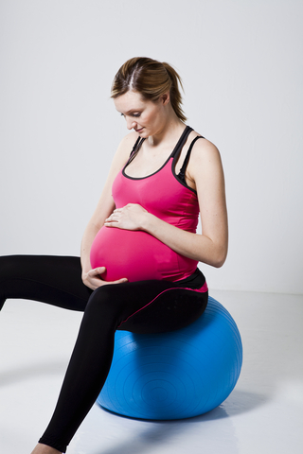
Acupuncture can help you prepare for birth but come sooner rather than later – ideally weekly from 36 weeks to get maximum benefit.
Many women approaching their date for hospital induction seek acupuncture as a more natural method of induction. However, the real benefit of acupuncture is achieved by focussing on preparing for birth, rather than on induction. Acupuncture can play a positive influential role in helping you to prepare for birth both physically and emotionally, increasing the chance of things starting and progressing naturally.
Midwives have reported that acupuncture treatment starting at around 36 weeks and focussed on preparation for birth can make a significant difference, reducing the need for induction as well as other interventions. They report specific effects following acupuncture treatment, such as changes in the cervix, position of the baby and positive emotional shifts that they observe have a direct beneficial effect on the resulting labour. Even if intervention is needed to induce labour, having acupuncture to help you to prepare for the birth can increase the chances of your birth progressing without further intervention.
How can acupuncture help?
Treatment will be tailored to your individual needs but can help with the following:
- Help the cervix to ripen (the points are not anywhere near your cervix!)
- Encourage your baby to move into the optimal anterior position
- Aid relaxation and softening of the tissues that help to prepare the pelvis and cervix for birth
- Help you to feel calm which has a physical effect too
- Encourage release and build-up of endorphins to help with pain relief
- Deal with any other symptoms that may be troubling you
- Help you to be at your best and well rested in readiness for the birth
The importance of feeling positive and calm
Acupuncture can help you to feel calm and relaxed. There may be fears about the labour and maybe also other issues that are worrying you. By helping you to feel calm it is less likely that labour will be delayed and more likely that once started labour will proceed uninterrupted.
What if I come at 40 weeks or more, is it too late?
Even if you come at 40 weeks or more, my focus will be to find out how you feel and help you to prepare for the birth, both physically and mentally. Treatment is be similar to earlier preparation treatments and can still be of great value. If you are facing an imminent hospital induction then, with the consent of your midwife or obstetrician, it may be appropriate to add points aimed at gently stimulating the onset of contractions.
Acupressure for Natural Pain Relief in Labour
You may also be interested in finding out how you and your partner can use acupressure for natural pain relief during labour. Please contact me if you would like to know more.
References:
Summary of research into acupuncture during pregnancy and acupressure during labour: https://acupuncture.rhizome.net.nz/acupuncture/practitioner-resources/patient-handout/
Betts D, Lennox S. Acupuncture for prebirth treatment: An observational study of its use in midwifery practice. Medical acupuncture 2006 May; 17(3):17-20
Rabl M, Ahner R, Bitschnau M, Zeisler H, Husslein P. Acupuncture for cervical ripening and induction of labour at term – a randomised controlled trail. Wien Klin Wochenschr 2001; 113 (23-24): 942-6.
Smith CA, Collins CT, Crowther CA, Levett KM. Acupuncture or acupressure for pain management in labour. Cochrane Database of Systematic Reviews 2011, Issue 7. Art. No.: CD009232. DOI: 10.1002/14651858.CD009232.

