Acupuncture for Hayfever – start now!
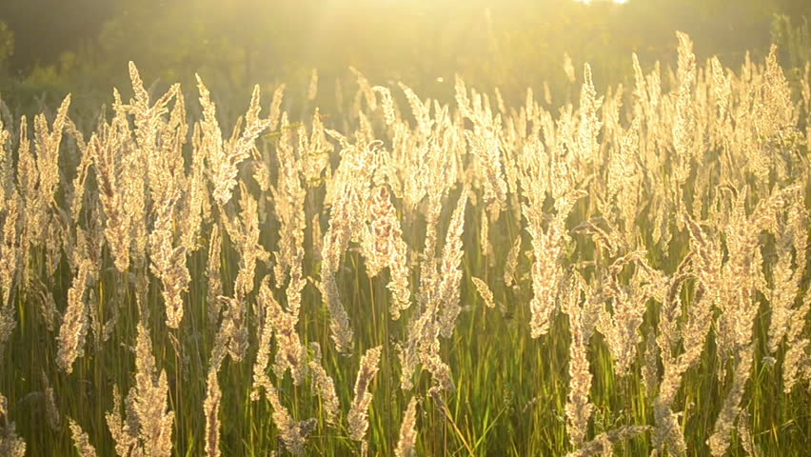
Hayfever may be the last thing on your mind right now, as snow falls and the temperatures plummet, but now is the time to take preventative measures to reduce symptoms once the pollen emerges. Spring and summer can be a time of dread for anyone who suffers from hayfever, or seasonal allergic rhinitis to give it its proper medical name. Runny nose, itchy eyes and nose, blocked nose and sinuses, headaches and sneezing can seriously hamper your enjoyment of the summer months, affecting work, school, exams and leisure activities. Most people rely on antihistamines to get them through but they don’t work for everyone and can have unwanted side effects, including impaired thinking and drowsiness.
Acupuncture offers an alternative, with well researched evidence of its effectiveness, helping to reduce the symptoms and reliance on medication without the side effects. Treatment focuses on both the symptoms and underlying imbalances that predispose people to allergies, which may also involve other conditions like asthma which are easily exacerbated by airbourne allergies. The selection of points vary from person to person, and are individually tailored to you.
Acupuncture works via a range of mechanisms including reducing the activity of an antibody (IgE) and other pro inflammatory markers associated with allergic reactions and is effective against allergies that persist all year round, like those caused by house dust mites. Unlike antihistamines, which supress the histamine response these treatments are aimed at moderating your immune system’s response to the allergen at a deeper level with longer lasting benefits.
It is best started before the season kicks to moderate the immune response before it goes into overdrive but can also help once symptoms have begun. The effects last for several weeks after treatment has ended so in the case of the grass pollen season, which can continue until September, a couple of extra top up sessions throughout the summer may be helpful.
What is acupuncture like?
For those of you who have not tried acupuncture before, it is a very gentle treatment using very fine hair like needles - nothing like injection needles. You may feel a momentary dull ache that lasts for a second and then you shouldn’t feel the needles at all as you lay back on our heated couch, relax and listen to some music for 25 minutes. I have treated many people who ‘don’t like needles’ and they have all found it a much more comfortable and relaxing experience than they ever expected. Surprise yourself!

