Self-massage at home
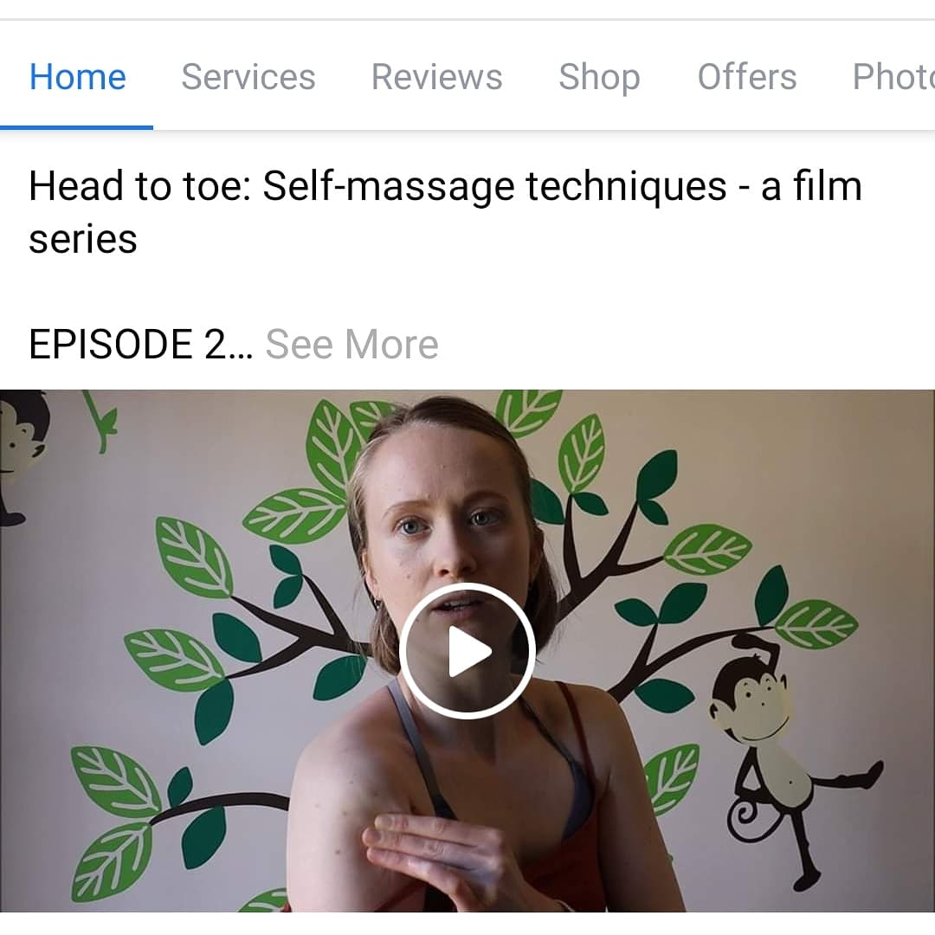
For many of us we are maybe not moving or playing sports as much as we used to in this new ‘stay at home age’. While you may be mourning the loss of your gym sessions or time on the field with the team, this could actually be a beneficial step back for your body. An enforced rest and re-set period if you will. Take this time to connect and strengthen the deeper muscles, perhaps through yoga or pilates, and work to create a healthy, functioning body. Trust me, it will thank you.
It is unlikely that you would need a vigorous sports massage at this time so instead I have been focusing on gentle self-massage techniques to release tension and stress that may have built up from the current situation. Whether you are one of our amazing key workers and feel a bit tired and worn-out when you come home, or whether you are working from home in a not-so-ergonomic-set-up, I hope this blog post will help you in some way.
I’ll start with ways to release tension that is probably caused by stress. Make sure the room you are in is warm and that you are comfortable. The best time for a self-massage is after a bath or maybe even in the bath depending on which area of the body you are massaging. I tend not to use any oil when massaging myself, but if you want to use oil then you probably have olive oil in the house; that works just fine.
Most stress-induced tension tends to centre around the head, neck and shoulders. Let’s start by lightly massaging our temples. Using your thumbs apply very light pressure in circular motions at your temples and then slowly move these circles up along your hairline so that your thumbs meet in the middle. Swap your thumbs to your index fingers, one on top of the other, at the top centre of your forehead. Moving down the middle of your forehead press lightly at intermittent points and then separate your fingers to move fluidly up over your eyebrows and circle your temples again. You are back where you started! You can repeat this as many times as you like and it could help with relieving mild headaches and tension.
Quite a few people hold tension in their jaw and a good way to release this is to use your knuckles to apply pressure to the area just below your cheekbones and just in from where your jaw hinges. You should feel it when you get the right spot – your whole jaw should ache. Apply pressure for 10-20 seconds and it will feel great when you release.
Get into those upper traps, the thick band of muscle that sits on top of your shoulders and goes up into your neck, by simply squeezing the muscle between your fingers and thumb. You can be pretty vigorous with this one, don’t be afraid to really ‘pick up’ the muscle and give it a good squeeze and wiggle around.
Lastly, make sure that you are not neglecting the front of the body. If most of your working day is spent sat at a computer, sat at a cashier desk, or bent over caring for patients, then it is great to stretch and open out across the front of the shoulders and chest with a shoulder mobility exercise. All you need is a belt or scarf, anything that is long, thin and straight. Start by holding the object at either end so that you are holding it taut and out in front of you at shoulder height. Keeping your arms straight take the object up and over your head and all the way down so that your arms are now almost back by your sides. Then simply reverse the movement to bring the object back in front of you. You should have felt a lovely opening across the chest and a stretch for the front of your shoulders.
For a bonus massage where you don’t have to do the work(!), try using a tennis ball or something similar to get into trigger points in your back or shoulders. Simply lie down on the floor and place the tennis ball under your back, finding the points that are most uncomfortable – these are the areas that need it! Keep the ball in place until the sensation decreases and you feel that point has been released. Just be careful not to place the ball directly on your spine. If you have a smaller, harder ball this can be used to roll under your feet to give you a nice foot massage.
All of these exercises are just suggestions. Please use your own discretion when self-massaging or stretching, and never continue through pain.
I hope some of these techniques and exercises will help you whilst stuck at home and if you’d like to delve into more, I am releasing tutorial videos. Titled ‘Head to Toe: Self – massage techniques’, the series is split up into different episodes that each focus on a different part of the body. I have already released 3 episodes that have focused on Head and neck, Shoulders, and Back. I will continue to make them until I get down to the feet! You can find the videos on my Facebook page, just search Sportsmassagesos. Or alternatively each episode is attached to its own blog post on my website: www.sportsmassagesos.com. If you have specific goals in mind and want to work through something 1-1, I am also offering 1-1 online sessions through zoom. These can include anything from postural exercises to improving your flexibility. For more information and to book just drop me an email at: sportsmassagesos@gmail.com. Stay safe and healthy.

