Tennis injuries – part 2 – Bursitis of the shoulder

The shoulder is a very shallow ball and socket joint which means it is highly mobile but not very stable. Muscles provide most of the joint stability. The most common shoulder injuries in tennis players are disturbance of soft tissues - and cartilage - caused by overuse or underuse. Injury may also arise from a degenerative breakdown of tissues which are no longer functioning well. The most common shoulder overuse injuries are rotator cuff strain, impingement and bursitiBursitis is inflammation of a small flat sack of synovial fluid called a bursa (meaning “purse”). A bursa’s job is to reduce friction, usually between a tendon and bone. In the shoulder joint there are several bursae, due to the fact that there are many structures whose paths cross very close to each other. The subacromial bursa lies between the acromion (the bony prominence which hangs over the ball and socket joint like a protruding roof) and the supraspinatus tendon. A portion of this bursa lies between the deltoid muscle and the humerus.

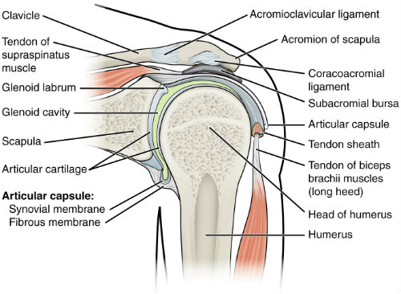

When the bursa is repeatedly compressed it can become painfully irritated, though this is not always the case and research is currently underway to find out why some people develop bursitis and some do not. For many people, however, bursitis is triggered by overuse of the arm in the overhead position.

Symptoms are as follows:
- Gradual onset of your shoulder symptoms over weeks or months
- Pain on the outside or top of your shoulder
- Pain may spread down your arm towards the elbow or wrist
- Pain made worse when lying on your affected shoulder

Treatment
Bursitis is traditionally treated with ice compresses, rest, and anti-inflammatory and pain medications (as prescribed by your GP). However, a functional approach is very useful to understand how and why the bursa has become inflamed, and sports massage treatment can assist. This usually incorporates mobilisation of the upper back and the shoulder girdle, and massage into the affected areas. Because bursitis is usually caused by repetitive compression, the key thing is to work out which specific movements are aggravating the bursa, and it’s worth noting that often more than one structure is affected. Then, working with your tennis coach, it’s possible to retrain the shoulder, improve movement and say goodbye to pain and dysfunction.

Most bursitis is non-infectious, but in rare cases infective bursitis requires aspiration of the bursa fluid. In cases of longstanding bursitis, it may be treated with an injection of cortisone medication, which is typically performed by orthopaedic surgeons. If your shoulder is hot and/or red then it is best to see your GP before visiting us.

--

