What is a Ganglion Cyst?
A ganglion cyst is a fluid-filled swelling that usually develops near a joint or tendon. The cyst can range from the size of a pea to the size of a golf ball.

What does it look and feel like?
Ganglion cysts look and feel like a smooth lump under the skin. They're made up of a thick, jelly-like fluid called synovial fluid, which surrounds joints and tendons to lubricate and cushion them during movement.
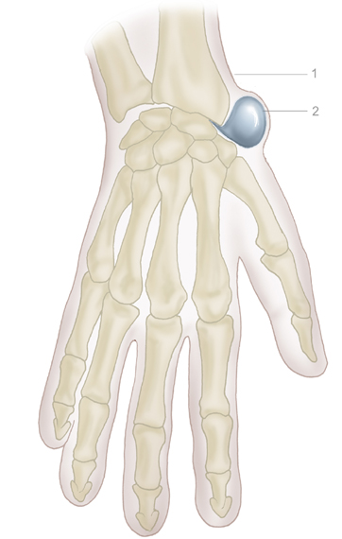
Ganglions can occur alongside any joint in the body, but are most common on the wrist (particularly the back of the wrist), and the hand and fingers.

Why did I get one?

It's not clear why ganglions form. They seem to occur when the synovial fluid that surrounds a joint or tendon leaks out and collects in a sac.

Will it go away?

Ganglions are harmless, but can sometimes be painful. If they don't cause any pain or discomfort, they can be left alone and may disappear without treatment, although this can take a number of years.

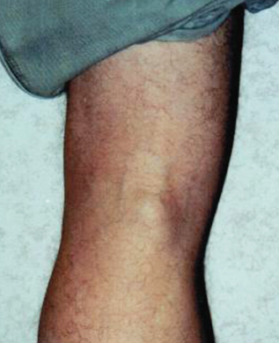
Treatment options
Treatment is usually only recommended if the cyst causes pain or affects the range of movement in a joint.

The two main treatment options for a ganglion cyst are:
- draining fluid out of the cyst with a needle and syringe – the medical term for this is aspiration
- cutting the cyst out using surgery

The NHS will not cover removal of a ganglion cyst unless it is very painful or disrupts daily activities.
If you want to have a cyst removed for cosmetic reasons, you'll probably have to pay for private treatment.

The area is sometimes also injected with a dose of steroid medication to help prevent the ganglion returning, although there's no clear evidence this reduces the risk of recurrence. In fact over a half of these cysts treated using aspiration return at some point. If a cyst does return, surgery may be necessary.

Lasting pain or stiffness may need further treatment with massage or physiotherapy.
How much time you need to take off work after surgery to remove a ganglion cyst largely depends on where the ganglion is and your job. If your job involves manual labour, you may need to take time off. You can usually start driving again once it feels safe.

NB: If you’re worried about any lumps that have appeared on your body always consult your GP.

Tessa Glover is one of our sports & remedial massage therapists working 8-12 and 3-7 on Thursday and 6-9pm on Friday. She also holds clinics on the second Saturday of the month.

Information provided by our wonderful NHS.

