The London Marathon 2019
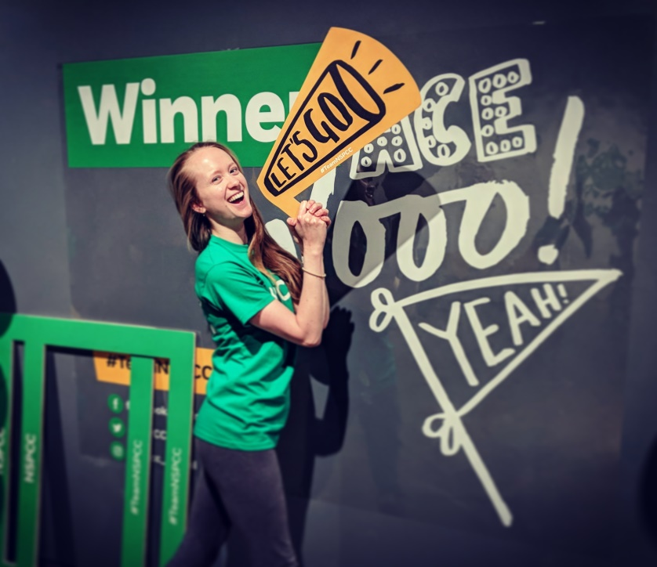
Last year I volunteered with NSPCC, giving post event massage at the London Marathon 2018. It was such a fulfilling experience that this year I went back for more and I couldn’t wait to put my green t-shirt back on! As you can probably remember, 2018 was the hottest London Marathon ever recorded. Water stations started running out of water and medical teams had their busiest year treating heatstroke. This year already looked to be shaping up for a stark contrast on the weather front. With strong winds and heavy rain dominating the weather forecast, I prepared to massage some soggy windblown runners!

Waking up this morning to calmer winds and a nice fresh feel in the air might have tricked some runners into thinking they were still dreaming! Pretty ideal weather conditions for long distance running. So far so good. I was feeling positive as I walked through Trafalgar Square and looking forward to working with Chris and the team again. After a quick hip loosening demonstration, Chris talked about posture and how to maintain good form. It’s all about keeping that chest forwards and proud!

At around 12:45 we applauded the first runner into our massage area. There was then a slow trickle of runners for about half an hour before the trickle turned to a steady stream and all 20 massage therapists were working flat out to ease the aches and pains. The atmosphere in the room was absolutely buzzing; you could almost feel a physical energy to it. Congratulations and elations never ceased and every time someone came up to me, no matter how exhausted they were, they had a smile on their face and such a sense of pride in what they had just achieved. Not one person was moaning or grumbling about any pain they were in, their achievement seemed to lift them above it.

At events it is likely that you will be massaging through clothes and there are several techniques to achieve great results with this. One of them is simply compressions and you can even try these on yourself (mainly on the legs) after a hard training session, event or performance. Simply use the heel of your hand or make a fist and press down on the muscle using your other hand to create the force, holding the compression for 10 - 20 seconds. Vibrations can also be another useful tool, as well as pin and stretch – compressing a muscle when contracted and then slowly extending the muscle whilst keeping the compression; something I like to use on the hamstrings especially and it can be done passively or actively.

Conversations with the runners sometimes verged on hysteria due to adrenaline and exhaustion! However the main topic of the day was their appreciation for the overwhelming support they received: from the crowd, from the charity, from their friends and family and from us! Times didn't matter. They had just run 26 MILES. I chatted to one runner who was running a marathon for every month of the year...that’s 314 miles this year! What an incredible human feat let alone the amount of money raised for charities. The 500 runners for NSPCC today raised £1.1 million between them. What an amazing event to be part of.

Even though it was a long and tiring day, I went home ecstatic and full of inspiration from everybody I had met, runners and volunteers alike. Just knowing that I had helped some of those amazing people in some way gave me my own sense of pride and achievement.

If you ever get the chance to volunteer with a charity at an event like the London Marathon, DO IT. You’ll find me massaging next at the Windrush Aquathlon on Sunday 30th June at the West Norwood Therapies stall. If you’re racing come and see me for some post event massage! If you’re there supporting, come and say hi to some of the team – we offer a whole range of complimentary therapies and classes.

