What value do we place on health and wellbeing - and who is responsible for our health?

By West Norwood Therapies Team, Dec 20 2017 09:00AM
Massage therapist and Yoga teacher Erika Zettervall considers how we approach our own health and wellbeing, the value we place on it and who is ultimately responsible for it.

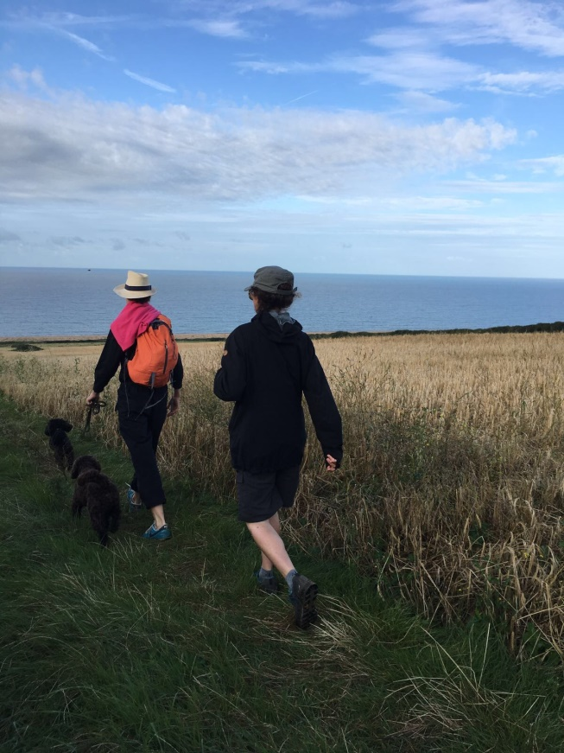
Prevention better than a cure the saying goes. How do you relate to health and maintaining healthy and who is responsible for your health?

These questions are becoming increasingly relevant with the rise of self employment in its various forms; The sole trader like me and fellow therapists, the entrepreneur, the freelance contractor and then of cause the so called self employed who are tied into rather rigid contracts without many freedoms or benefits. The importance of keeping well is paramount, we soon become aware when bout of flu can be costly and set you back due to loss of earnings.

There are no sickies to pull or take. At least the actual care needn't break the bank since we here in the U.K. we have a free health care at the point of use.

It is a remarkable thing, and gives a tremendous sense of safety and security. As far as I know, no there is no other country where this is the case, though I only have direct experience of Scandinavia and France, where there are various tariffs and fees that are reclaimable but still have to pay upfront, and the extreme in the US where the cost of health insurance can be crippling and unattainable.

The downside of anything being for free is that we easily loose sense of its value and becomes taken for granted. In this instance perhaps rightly so as a part of a civilised society but this may be the reason for UK citizen spending very little of their own money on their health, the least per capita in the industrial world I read somewhere. If this is the case there might be room for an adjustment in how we value keeping well and what should be provided for free. When you are well it's also hard to appreciate just how great that is, only when you fall ill its clear what you lost. This is the dilemma with preventative care as we can't know what we avoided but but care shouldn't be seen as selfish, rather being responsible.

When I first had massage in the UK back in the 1990s, it was very mainly seen as an extension of beauty treatment not viewed as part of your health care.

In the rest Europe it has been seen as a normal part of routine maintenance for body and soul for a long long time. Something just as natural as taking exercise, vitamins, sauna and a washing hands in order to keeping well and strong.

The term massage has also unfortunately at times been hijacked and used to cover for something different al together. Attitudes are different now, but still there is a bit of frivolous about having massages and sometimes seen as a guilty pleasure rather than servicing your energies and wellbeing to maintain in good health.

But I have friends with aches and pains in the body who find resource, time and money, for hair removal, high heels and dining out but not for a massage. It's of cause our individual and different sets of priorities and preferences that determines our choices.

I have always valued experiences more than things and making that that priority but also made
myself dependent on good health for making a living.

My basic check lists: how do I eat, sleep, move and eliminate. Keep it simple and find help and support. Be kind to yourself and don't see a treatment as a guilty indulgence but as treat and care of yourself to live well.

